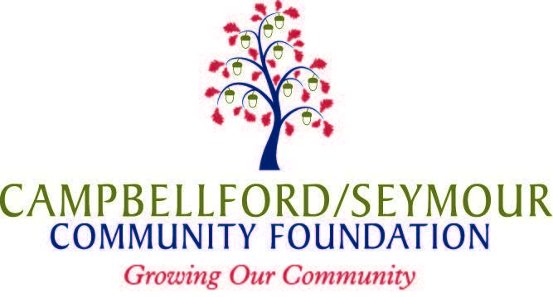
Job Opportunity for Youth
GRANT APPLICATION
ALL FIELDS ARE MANDATORY
INCOMPLETE APPLICATIONS WILL NOT BE ACCEPTED
PLEASE TYPE IN THE SPACE PROVIDED

Date: M/dd/yyyy
Part A: Registered Charity or Qualified Donee:

Organization Name
Street Address |  | PO Box
Town |  | Postal Code
Primary Contact |  | Title
Phone # |  | Fax #
Email |  | Website
Approved by Authorized Representative | Name  Title
Charitable Registration # |  |  | Your # Sponsor’s #

Sponsored Organization (If applicable):

Organization Name
Street Address |  | PO Box
Town |  | Postal Code
Primary Contact |  | Title
Phone # |  | Fax #
Email |  | Website
Approved by Authorized Representative | Name  Title

Letter of Support from Registered Charity or Qualified Donee attached: Yes No If no, when expected:

Part B: Organization Background
Tell us what the organization(s) involved in the project do in our community:

Part C: Job Opportunity for Youth Employment Plan
Youth Position
Brief overview of the position:
Expected hours per week: |  | Expected number of weeks: | Wages: $ / hour (Salary is to be based on minimum wage)
Amount Requested | $ (Maximum $5,000)
Period this Grant Covers | Start Date: End Date:

Outline the Work and Learning Plan:
How will you maximize training, job skill development and hands-on experience in each of these career readiness skills? | Communication Skills
 | Teamwork
 | Decision Making Skills
 | Lifelong Learning Skills
 | Professionalism
 | Occupational or Technical skills
How to you intend to engage the student in each of these support strategies? | Meaningful Participation:
 | Sustained Involvement:
 | Structured Activities:
 | Adult Support/mentoring:
 | Project Completion:

Job Opportunity for Youth Budget Summary
Expenditures (*HST excluded) | Cost | Check for expenses to be covered by grant
Student Wages | $
Source Deductions | $
*Advertising for position | $
*Other - | $
*Other - | $
Total Project Expenditures | $

Have you applied to any other fund provider for this particular project? Yes No
If yes, please identify funder and amount of request.

Payment Schedule – Please indicate approximate dates grant funding will be required (After May 1st)
Note: Grant funding will be paid in 2 – 3 installments, contingent on receipt of interim reports.
1st Installment | m/dd/yyyy
2nd Installment | m/dd/yyyy
3rd Installment | m/dd/yyyy

Attachments and Check List:

Sponsored Organizations:
Letters of support from Registered Charity or Qualified Donee

New Applicants only:
List of Board of Directors
Summary of current year operating budget for your organization
Most recent (audited or un-audited) financial statements and Annual report (if published)

(Note: The Community Foundation may request additional information from previous applicants who have not received a grant in the past 5 years)

How to Apply:
E-mail (preferable) your application and attachments to admin@cscf.ca by the deadline date.
Please save your Application as: Year-Project Name-Report Name. (i.e. 2017-MarketingAssistant-Application)

For further information contact:
Martha Murphy, Executive Director or Pamela Vandesteeg, Executive Assistant at 705-653-2005

